**AcqManager**

**Data Processing (*Online Filtering*)**

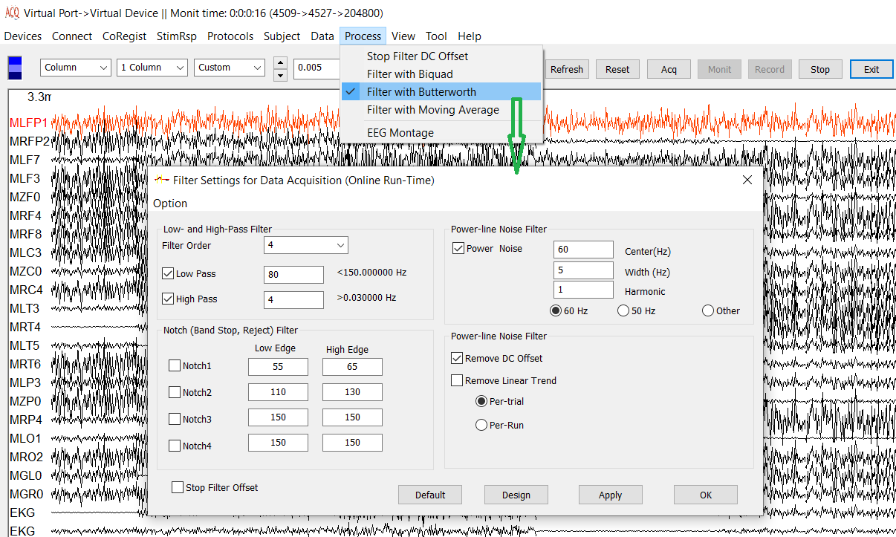

DISCLAIMER

We have used reasonable effort to include accurate and up-to-date information in this manual; it does not, however, make any warranties, conditions or representations as to its accuracy or completeness. We assume no liability or responsibility for any errors or omissions in the content of this manual. Your use of this manual is at your own risk. Under no circumstances and under no legal theory shall the authors be liable for any indirect, direct, special, incidental, punitive, exemplary, aggravated or consequential damages arising from your use of this manual.

Features and specifications of this software program are subject to change without notice. This manual contains information and images about AcqManager, its user interface, GUI and its other signal processing algorithms, publications that are protected by copyright.

All rights reserved. This publication may be reproduced, stored in a retrieval system, or transmitted, in any form or by any means, electronic, mechanical, photocopying, recording, or otherwise, with prior permission by the authors.

*Sending Your Comments and Critiques:* We’d like to hear from you. Your comments and suggestions for improving this document are welcome and appreciated. Please e-mail your feedback to support@mecurer.com

Thank you.

Contents

*Warnings and Cautions* 4

Preface 5

Using Menu to Process Data (online or run-time) 6

Stop Filter DC Offset 6

Filter with Biquad 6

Filter with Butterworth 7

Filter with Moving Average 9

EEG Montage 10

# *Warnings and Cautions*

This software supports data acquisition for magnetoencephalography (MEG), electroencephalography (EEG) and other bioelectromagnetic signals. Though MEG and EEG waveforms appear similar, they have different unit in amplitude. If the MEG and EEG data recorded simultaneously, their time unit or temporal resolution is typically the same.

Modern MEG/EEG systems typically have MEG/EEG sensor/electrode channels as well as other channels. For example, trigger channel, head-localization channels and additional ADC (analog-to-digital) channels. To avoid problems, please pay attention to the channel names and the amplitude value/unit. Their values may be of different orders of magnitude. Unexpected results may occur if their values are mixed in measurements.

When performing waveform analysis, regardless of whether MEG or EEG or both are displayed, ensure that the data are appropriately filtered with DC-offset/linear-trend removal. If the waveforms had very large amplitude (e.g. > 3 pt), it is recommended that you identify possible noise.

There are a set of source localization algorithms in the program. Each source localization algorithm has been designed and tested for specific reasons. To ensure the quality and visibility, all source localization algorithms will generate a volumetric source image, which can be considered as an image with millions of “dipoles” or multi-value-voxel, which is significantly different from the conventional magnetic source imaging (MSI) or equivalent current dipoles.

Head movement during MEG recordings may affect the accuracy of source imaging. If subjects move too much during MEG recordings, the MEG results are more than likely poor.

The accuracy of the structural images (MRI/CT) may also affect the MEG results if the conventional magnetic source imaging (MSI) is used. If MRI/CT is distorted, the combination of MEG/MRI/CT will be low-quality. In addition, multiple local sphere, head model or other structural constrained source localization my internally use the MRI/CT images. Any analysis based on those distorted images may yield unexpected or poor results.

The following warnings and cautions appear in this guide. Please ensure you are aware of all the operations and interpretations.

# Preface

The Main Frame is one of the core windows of AcqManager software. It is used as the primary tool to view MEG, EEG, MCG, ECG, triggers and other data, mark and classify the data, and identify results of interest for academic or clinical purposes. Importantly, the Main Frame provides graphic user interface (GUI) for access other function. In other words, it is also often used to launch other windows such as source localization.

This guide describes the operation of the AcqManager application for MEG/EEG/MCG/ECG. Though there are many functions related to MRI/CT, analyses of MRI/CT are not the focuses of this guide.

*Determining the Software Version*

In the Main Frame: select Help -> About.

The About Dialog will show the version of the software.

*Intended Audience*

This guide is intended for anyone needing to record and view (online) data with an appropriate hardware system. It assumes the technologist/operator is familiar with standard MEG/EEG/MCG/ECG procedures and with the Windows operating systems.

*Document Structure*

Documents are generally provided in both Microsoft Word® format and Adobe® Acrobat® PDF (Portable Document Format). All editions are distributed on Flash Driver, CD or websites with the related software, and include bookmarks and hyperlinks to assist navigating the document. Please feel free to send your critiques, corrections, suggestions and comments to support@mecurer.com.

*Conventions*

Numeric: Numeric values are generally presented in decimal but in special circumstances may also be expressed in hexadecimal or binary. Hexadecimal values are shown with a prefix of 0x, in the form 0x3D. Binary values are shown with a prefix of 0b, in the form 0b00111101. Otherwise, values are presumed decimal.

Units: Units of measure are given in metric. Where measure is provided in imperial units, they are typically shown in parenthesis after the metric units. Biomagnetic signal strength is given in Teslas (T), the SI unit of flux density (or field intensity) for magnetic fields, also known as the magnetic induction. Typical signal strengths in biomagnetic measurements are in the order of pT (picoteslas = 10-12) or fT (femtoteslas = 10-15). Electrical signal strength is given in volts (V). Bioelectrical activity is typically quite small, measured in microvolts (mV).

# Using Menu to Process Data (online and run-time)

This menu provides online data processing. One of the important functions is Filters, which enables to visually identify brain activity during data acquisition.

Filters are essential to the operation of most electronic circuits. Filter is a device or process that removes unwanted components or features from a transmitted signal. Most often, this means removing some frequencies and not other to suppress interfering signals and reduce background noise. Filters are classified according to the functions that they are to perform, in terms of ranges of frequencies. In circuit theory, a filter is an electrical network that alters the amplitude and/or phase characteristics of a signal with respect to frequency. Ideally, a filter will not add new frequencies to the input signal, nor will it change the component frequencies of that signal, but it will change the relative amplitudes of the various frequency components and/or their phase relationships. Filters are often used in electronic systems to emphasize signals in certain frequency ranges and reject signals in other frequency ranges.

# Stop Filter DC Offset

The software allows stopping all filters and DC offset function with one click.

# Filter with Biquad

The Biquad Filter block independently filters each channel of the input signal with the specified biquadratic IIR filter. When you specify the filter coefficients in the dialog box, the block implements static filters with fixed coefficients. When you provide the filter coefficients through an input port, you can tune the coefficients during simulation. When you set the Input processing parameter to filter data in all channels (which are determined by hardware), the software will take care of the data in each channel separately.

The Biquad Filter block supports the Simulink state logging featureIn signal processing, a digital biquad filter is a second order recursive linear filter, containing two poles and two zeros. "Biquad" is an abbreviation of "biquadratic", which refers to the fact that in the Z domain, its transfer function is the ratio of two quadratic functions. High-order IIR filters can be highly sensitive to quantization of their coefficients, and can easily become unstable. This is much less of a problem with first and second-order filters; therefore, higher-order filters are typically implemented as serially-cascaded biquad sections (and a first-order filter if necessary). The two poles of the biquad filter must be inside the unit circle for it to be stable. In general, this is true for all discrete filters i.e. all poles must be inside the unit circle in the Z-domain for the filter to be stable. When a sample of n bits is multiplied by a coefficient of m bits, the product has n+m bits. These products are typically accumulated in a DSP register, the addition of five products may need 3 overflow bits; this register is often large enough to hold n+m+3 bits. The z−1 is implemented by storing a value for one sample time; this storage register is usually n bits, the accumulator register is rounded to fit n bits, and this introduced quantizing noise. Fixed point DSP usually prefers the non-transposed forms and has an accumulator with a large number of bits, and is rounded when stored in main memory. Floating point DSP usually prefers the transposed form, each multiplication and potentially each addition are rounded; the additions are higher precision result, when both operands have similar magnitude.

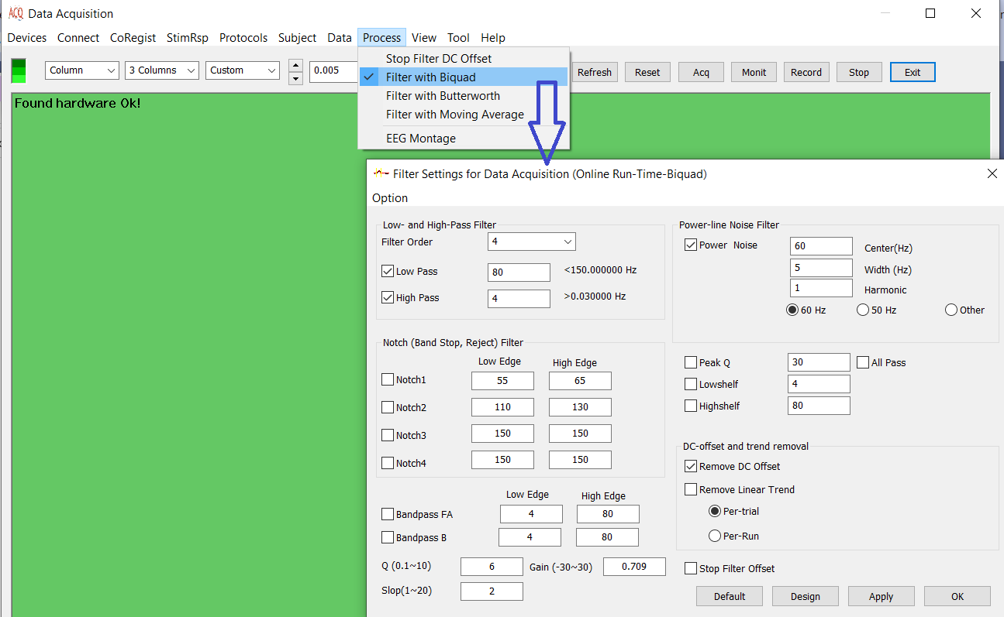Figure 1. Biquad Filter.

# Filter with Butterworth

The Butterworth filter is a type of signal processing filter designed to have as flat frequency response as possible (no ripples) in the pass-band and zero roll off response in the stop-band. Butterworth filters are one of the most commonly used digital filters in signal processing (e.g., MEG, EEG). They are fast and simple to use. Since they are frequency-based, the effect of filtering can be easily understood and predicted. Choosing a cutoff frequency is easier than estimating the error involved in the raw data in the spline methods. However, one main disadvantage of the Butterworth filter is that it achieves this pass band flatness at the expense of a wide transition band as the filter changes from the pass band to the stop band. It also has poor phase characteristics as well. The ideal frequency response, referred to as a "brick wall”. Since the Butterworth filter is a type of signal processing filter designed to have a frequency response that is as flat as possible in the passband, it is also referred to as a maximally flat magnitude filter. It was first described in 1930 by the British engineer and physicist Stephen Butterworth in his paper entitled "On the Theory of Filter Amplifiers”. Butterworth had a reputation for solving "impossible" mathematical problems. At the time, filter design required a considerable amount of designer experience due to limitations of the theory then in use. The filter was not in common use for over 30 years after its publication. Butterworth stated that:

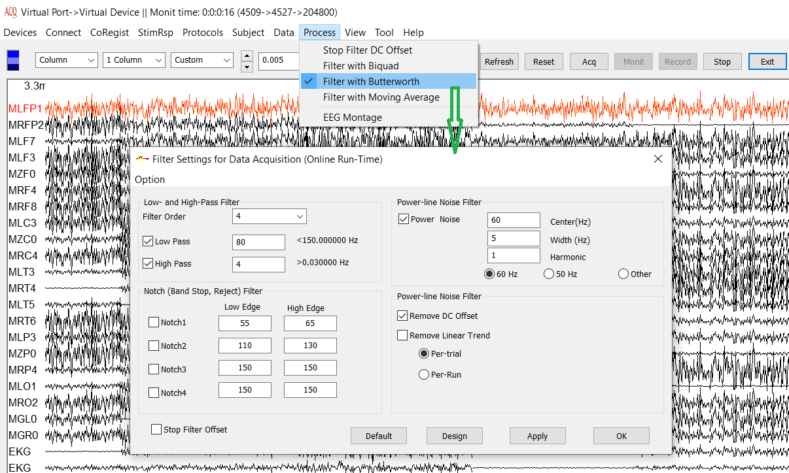Figure 2. Butterworth Filters

"An ideal electrical filter should not only completely reject the unwanted frequencies but should also have uniform sensitivity for the wanted frequencies".

Such an ideal filter cannot be achieved, but Butterworth showed that successively closer approximations were obtained with increasing numbers of filter elements of the right values. At the time, filters generated substantial ripple in the passband, and the choice of component values was highly interactive. Butterworth showed that a low-pass filter could be designed whose cutoff frequency was normalized to 1 radian per second and whose frequency response (gain) was where ω is the angular frequency in radians per second and n. n is the number of poles in the filter—equal to the number of reactive elements in a passive filter. If ω = 1, the amplitude response of this type of filter in the passband is 1/√2 ≈ 0.707, which is half power or −3 dB. Butterworth only dealt with filters with an even number of poles in his paper. He may have been unaware that such filters could be designed with an odd number of poles. He built his higher-order filters from 2-pole filters separated by vacuum tube amplifiers. His plot of the frequency response of 2-, 4-, 6-, 8-, and 10-pole filters is shown as A, B, C, D, and E in his original graph.

Butterworth solved the equations for two-pole and four-pole filters, showing how the latter could be cascaded when separated by vacuum tube amplifiers and so enabling the construction of higher-order filters despite inductor losses. In 1930, low-loss core materials such as molypermalloy had not been discovered and air-cored audio inductors were rather lossy. Butterworth discovered that it was possible to adjust the component values of the filter to compensate for the winding resistance of the inductors. He used coil forms of 1.25″ diameter and 3″ length with plug-in terminals. Associated capacitors and resistors were contained inside the wound coil form. The coil formed part of the plate load resistor. Two poles were used per vacuum tube and RC coupling was used to the grid of the following tube. Butterworth also showed that the basic low-pass filter could be modified to give low-pass, high-pass, band-pass and band-stop functionality.

# Filter with Moving Average

The moving average is the most common filter in DSP, mainly because it is the easiest digital filter to understand and use. In spite of its simplicity, the moving average filter is optimal for a common task: reducing random noise while retaining a sharp step response. This makes it the premier filter for time domain encoded signals. However, the moving average is the worst filter for frequency domain encoded signals, with little ability to separate one band of frequencies from another. Relatives of the moving average filter include the Gaussian, Blackman, and multiple-pass moving average. These have slightly better performance in the frequency domain, at the expense of increased computation time. In statistics, a moving average (rolling average or running average) is a calculation to analyze data points by creating a series of averages of different subsets of the full data set. It is also called a moving mean (MM)[1] or rolling mean and is a type of finite impulse response filter. Variations include: simple, cumulative, or weighted forms (described below). Given a series of numbers and a fixed subset size, the first element of the moving average is obtained by taking the average of the initial fixed subset of the number series. Then the subset is modified by "shifting forward"; that is, excluding the first number of the series and including the next value in the subset. A moving average is commonly used with time series data to smooth out short-term fluctuations and highlight longer-term trends or cycles. The threshold between short-term and long-term depends on the application, and the parameters of the moving average will be set accordingly. For example, it is often used in technical analysis of financial data, like stock prices, returns or trading volumes. It is also used in economics to examine gross domestic product, employment or other macroeconomic time series. Mathematically, a moving average is a type of convolution and so it can be viewed as an example of a low-pass filter used in signal processing. When used with non-time series data, a moving average filters higher frequency components without any specific connection to time, although typically some kind of ordering is implied. Viewed simplistically it can be regarded as smoothing the data.

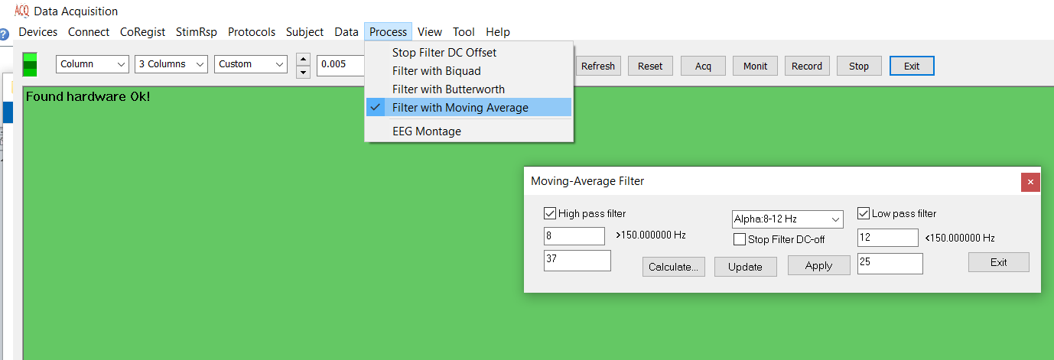

Figure 3. Moving-Average Filter

# EEG Montage

Montages are logical, orderly arrangements of electroencephalographic derivations or channels that are created to display activity over the entire head and to provide lateralizing and localizing information. Most often, bipolar and referential montages are used for routine electroencephalographic recordings. Common average and Laplacian montages can also be helpful in some situations. Because each type of montage has certain strengths and limitations, the ACNS guidelines recommend the use of multiple classes of montages for each electroencephalographic recording. A variety of factors need to be considered for localization by scalp electroencephalogram, but in clinical practice, a three-step approach can be used to localize an interictal epileptiform discharge by visual inspection using a standard set of scalp electrodes and conventional montages. The ACNS guideline provides a number of standard and suggested montages, but, depending on the clinical situation, additional montages can be designed using the electrodes within the 10-20 system or by placing additional electrodes.

**Index**

E

Electroencephalography (EEG), **5**

F

femtoteslas, 6

M

Magnetic source imaging (MSI), 5

Magnetoencephalography (MEG), 5

Main Frame, 6

P

picoteslas, 6

T

Teslas (T),, 6